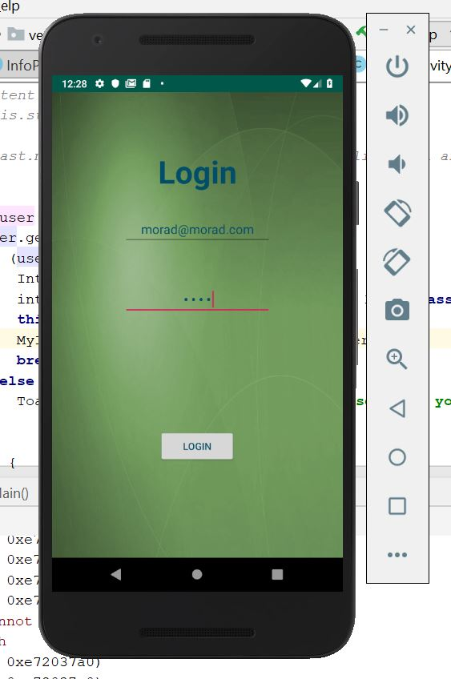

Vero App UI Navigating

Login UI :

This UI is operated by LogInActivity.class : it checks if the username and password is correct.

There are already three existing users :

Mail : [admin@admin.com](mailto:admin@admin.com) Password: admin

Mail : [george@geroge.com](mailto:george@geroge.com) Password: 1234

Mail : [morad@morad.com](mailto:morad@morad.com) Password: 1234

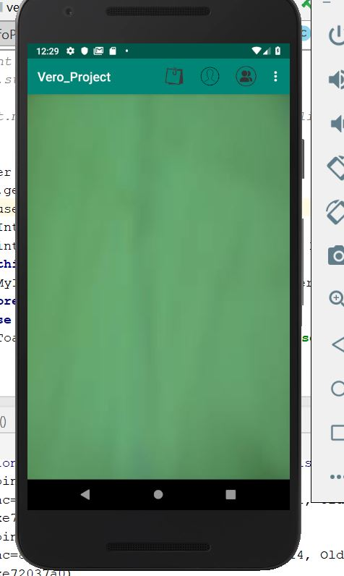

Friend Posts

User Profile

User friend

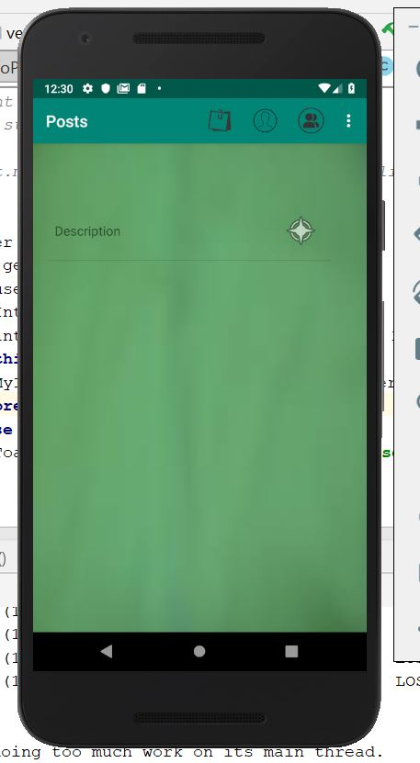

Friend Posts

Post Reply

Post Description

Friends Posts UI :

Main UI :

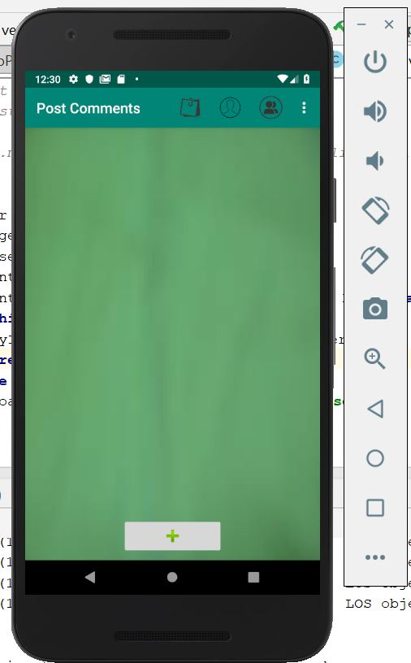

Add Reply

Replies list

Add Reply UI :

Post Replies UI :

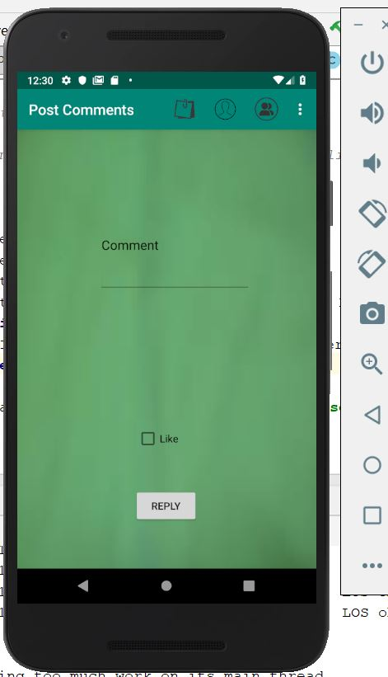

Add Reply

User Profile UI :

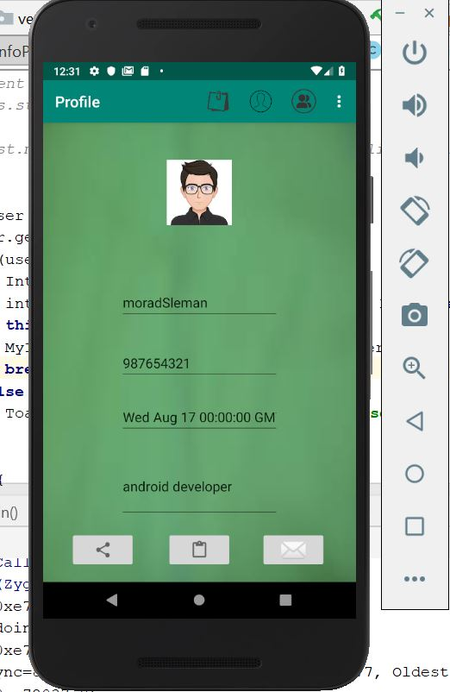

Followers

Requests

User Posts

Follow UI :

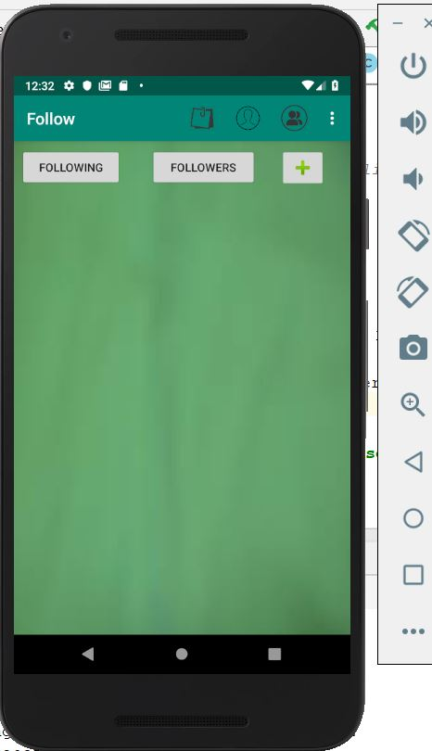

User Following

User Followers

Add Follower

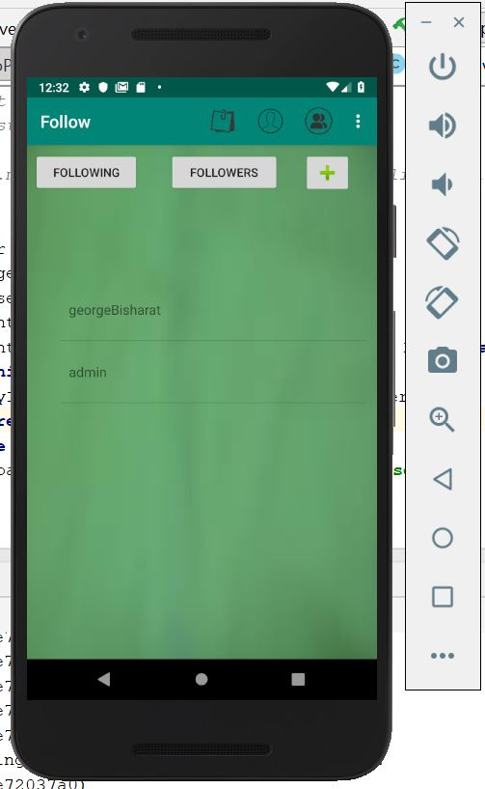

User Following

Friends UI :

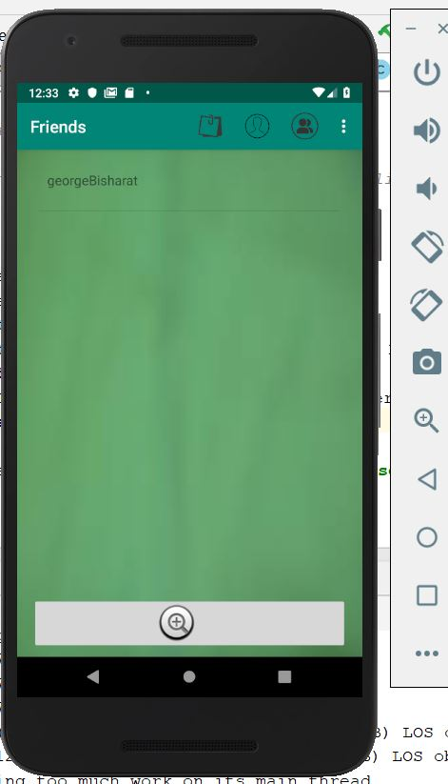

User friends

Add friend

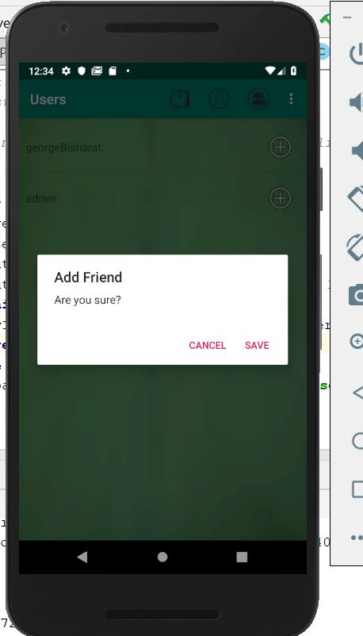

Add Friends(Rqeuest) UI :

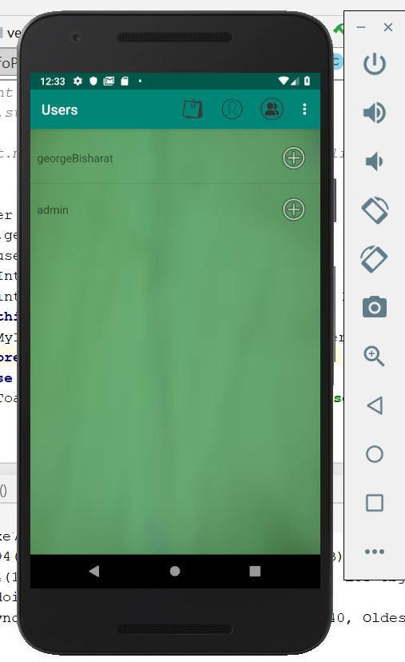

Send request to user in current position

Requests Management UI :

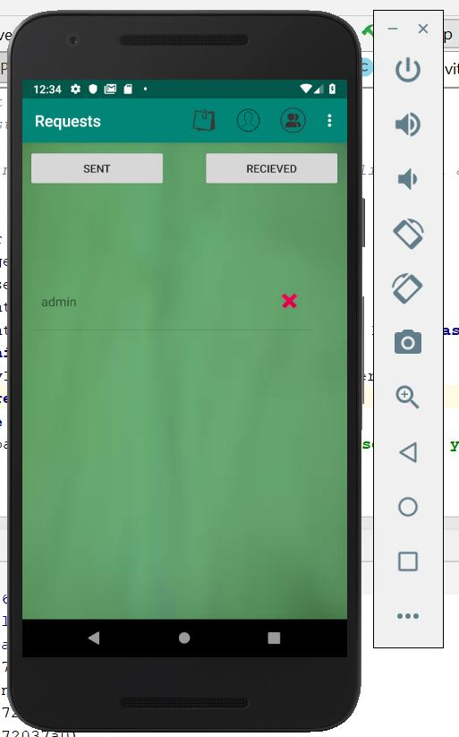

Sent requests

Remove

Requests sent to user in current position

User posts and new post UI :

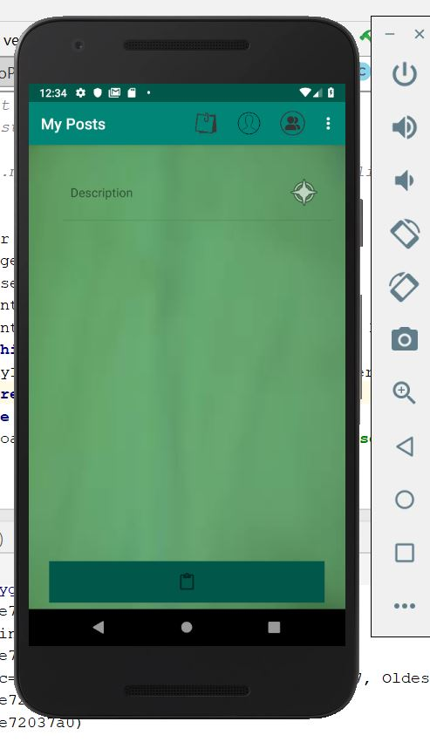

User Posts

Add post

Post replies

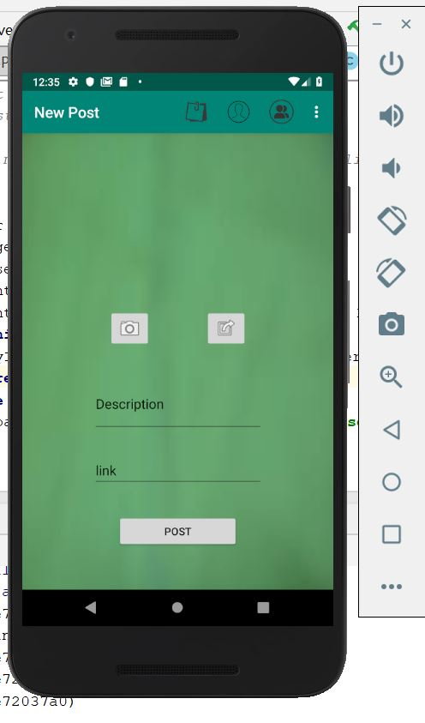

Browse for pic

Take pic